Detailed Design Document
Sponsor Name:
Document ID: Detailed Design Document_ Calibration
Blueprint Design Document ID: LIMS_Phase2_Blueprint Design_Calibration_CN_Final

Version No. | Authorized by | Approval date
1.00

Table of Contents
1 Table of Contents 2
1 Objective 4
2 Detailed Architecture 4
2.1 Instrument Calibration in SampleManager 4
2.1.1 Functionality Overview 4
2.1.2 Forms 5
2.1.2.1 Adding Test Items in Instrument Master Data 5
2.1.2.2 Instrument Calibration Plan Setup 5
2.1.3 Maintenance tasks 6
2.1.3.1 Viewing Maintenance Schedule 6
2.1.3.2 Scheduled Maintenance Trigger 6
2.1.3.3 Performing Instrument Calibration 7
2.1.3.4 Changing Status Manually 8
2.1.3.5 Internal Calibration 8
2.1.3.6 External Calibration 9
2.1.4 .NET Tasks 10
2.1.4.1 StartCalibrationTask 10
2.1.4.2 ChangeInstrumentStatusTask 10
2.1.4.3 UploadCalibrationTask 10
2.1.4.4 CalibartionResultSelectTask 10
2.1.4.5 CalibrationCompletionTask 10
2.2 Configuration Specification 10
2.2.1 Structure Table Updates 10
2.2.1.1 New Table: Hen_Test_Data 10
2.2.1.2 New Table: Hen_Item_Table 11
2.2.2 Master Menu 12
2.2.2.1 “Start Calibration Task” 12
2.2.2.2 “Upload Calibration Attachment” 12
3 Change Log 12

Objective
The purpose of this document is to describe the technical design for the Instrument calibration, which includes internal calibration and external calibration that are performed within the SampleManager application and the customizations in Instrument module.
The intended audience for this document is the development team, and anyone else who will be installing, configuring, and supporting the application.

Detailed Architecture

Instrument Calibration in SampleManager

Functionality Overview
Calibration Types
Internal Calibration: Performed directly by users within SampleManager.
External Calibration: Managed via document uploads from external sources.

Internal Calibration Workflow
Maintenance Task Generation:
System auto-generates tasks when calibration is due.
Email notification sent to the designated maintenance owner (single recipient only).
Instrument Master Data Configuration:
Users define:
Maintenance name
Test item name
Instructions
Specification limits (lower/upper) – Optional
Units – Optional
Maintenance Planning & Scheduling:
Test items are linked to a maintenance plan.
Schedules are displayed in the Instrument Maintenance Dashboard.
Calibration Execution:
Users initiate calibration via right-click on the instrument or Instrument maintenance.
The calibration window displays predefined test items.
Up to five measurement results can be entered per test item.
System calculates and displays the average value.
Specification limits are checked; out-of-range values are highlighted.
Final Pass/Fail decision is manually selected by the user.

External Calibration Workflow
Calibration Completion:
Users upload calibration certificates/documents via right-click action.
Upon upload, calibration is marked as completed.
Instrument status is automatically updated to "Available".

Forms

Adding Test Items in Instrument Master Data
Navigate to Instrument Master Data
Users access the Test Data page within the Instrument Master Data section.
Add Test Items
On the Test Data page, users can add the following details for each test item:
Test Item Name
Test Instructions
Plan
Lower Spec (optional)
Upper Spec (optional)
Unit (optional)
Usage of Test Items
The added test items are utilized during calibration execution, based on the defined maintenance plan.
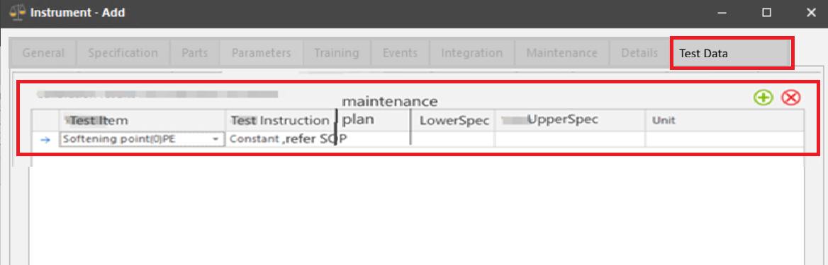

Instrument Calibration Plan Setup
Define Calibration Plan
  - Navigate to the Maintenance Page of the instrument.
  - Add a Maintenance Task:
    - Calibration Type: Internal Calibration or External Calibration.
Configure Maintenance Schedule
  - Go to the Scheduling Page.
  - Enter Maintenance Plan Information:
    - Specifies when the calibration must be performed.
Set Lead Time
  - Define the Lead Time:
    - This is the notice period before the maintenance task is due.
    - It determines the interval between the email notification and the due date.
Notification Mechanism
- SampleManager sends an email notification to the person listed in the Owner prompt.
- The email is triggered based on the Lead Time setting.

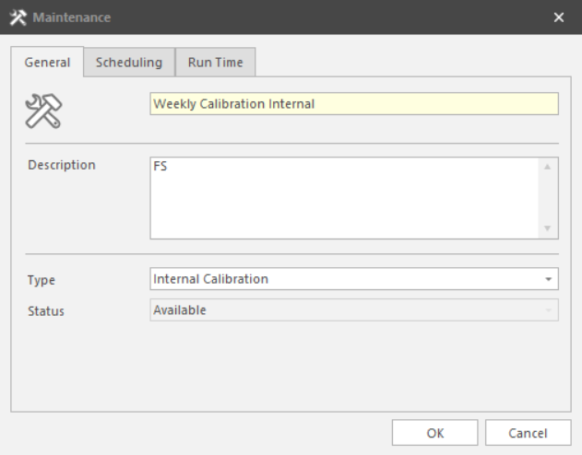
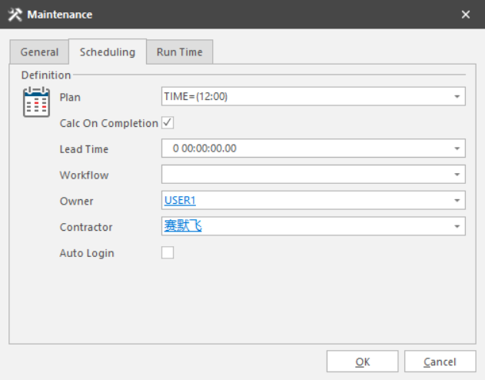

Maintenance tasks

Viewing Maintenance Schedule
Users access the Instrument Maintenance Overview Dashboard.
The dashboard displays the maintenance schedule for each instrument.

Scheduled Maintenance Trigger
When the scheduled maintenance time arrives:
The system automatically updates the Maintenance Status to: "Requires Maintenance"
The Instrument Status changes to: "Maintenance Due"

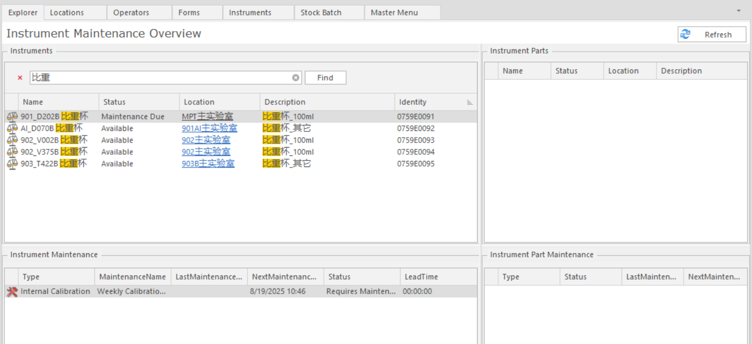
      - An instrument Maintenance dashboard has already been created.

Performing Instrument Calibration
Initiating Calibration
Users must use RMB (Right Mouse Button) option ‘Start Calibration Task’:
Applicable for both Instrument and Instrument Maintenance Item.
This action opens the Test Item form for calibration.
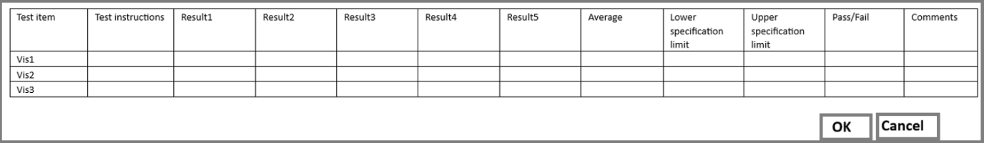
Loading Calibration Data
The system automatically loads:
Test Items
Test Instructions
Lower Spec
Upper Spec
→ These are fetched from the Test_Data table.
Entering Calibration Results
Users can enter up to five result values.
The system will auto-calculate the average based on the entered results.
Specifying Specifications and Outcome
Users can manually enter:
Lower Spec (If not loaded from Test_Data)
Upper Spec (if not loaded from Test_Data)
Automatically evaluate Pass/Fail status based on:
Entered Lower Spec and Upper Spec values.
The calculated average.
Users can also manually select Pass/Fail if needed.
Completing Calibration
Upon clicking OK:
The Calibration Task is marked as completed.
The Instrument Status is updated to:
“Available”

Changing Status Manually
If Calibration Result = Fail:
User changes the instrument status to Unavailable.
Comments are mandatory when marking an instrument as unavailable.
Predefine Logic is already available in system to make instrument as available/unavailable.
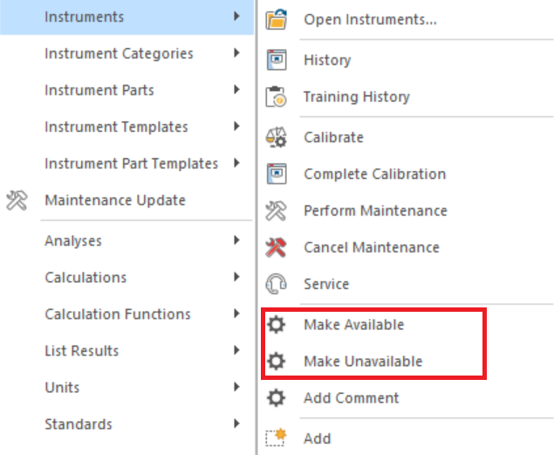

Internal Calibration - Attachment Task Completion Process in QCLAD
Step 1: Upload Calibration Attachment
- User right-clicks on the available calibration task.
- Selects “Upload Calibration Attachment”.
- Uploads the required calibration document.
Step 2: Calibration Result Selection
- QCLAD presents options to mark the calibration as Pass or Fail.
- User selects the appropriate result and clicks “OK”.
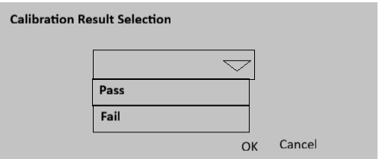

Step 3: Task Completion Confirmation
- QCLAD prompts the user with a confirmation window:
  - “Do you want to complete the calibration task?”
  - If the user clicks “OK”:
    - The calibration task is marked as Completed.
    - If Pass, the instrument status is updated to Available.
    - If Fail, the instrument status is updated to unavailable
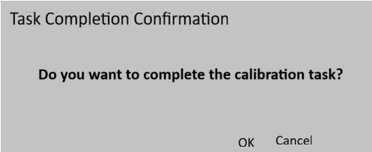

External Calibration - Attachment Task - Completion Process in QCLAD
Step 1: Upload Calibration Attachment
- User right-clicks on the available calibration task.
- Selects “Upload Calibration Attachment”.
- Uploads the required calibration document.
Step 2: Calibration Result Selection
- QCLAD presents options to mark the calibration as Pass or Fail.
- User selects the appropriate result and clicks “OK”.



Step 3: Task Completion Confirmation
- QCLAD prompts the user with a confirmation window:
  - “Do you want to complete the calibration task?”
- If the user clicks “OK”:
  - The calibration task is marked as Completed.
  - The instrument status is updated to Available.
    - If Fail, the instrument status is updated to unavailable


.NET Tasks

StartCalibrationTask
Used to start calibration task and pop-up the item table form for calibration task.

ChangeInstrumentStatusTask
Used to complete the calibration task and change the instrument status as available and add all the form table details to Hen_Item_Table.

UploadCalibrationTask
Used to upload calibration report to the available calibration task as well as generate pop-up window complete/Not Complete calibration task.

CalibartionResultSelectTask

CalibrationCompletionTask

Configuration Specification

Structure Table Updates

New Table: Hen_Test_Data
Field Name | Datatype | Comments
Instrument | links_to Instrument.identity; | Instrument to be added respect
Test_Item | links_to result.name; | Field to capture test item info.
Test_Instruction | Text (100) | Enter descriptive information of test as needed
Plan | links_to Maintenance.Plan; | Maintenance Plan
Lower_Specification_Limit | Numeric | Field will be optional and used for lower spec values
Upper_Specification_Limit | Numeric | Field will be optional and used for upper spec values
Unit | links_to unit_header.identity; | Select Unit from dropdown
MODIFIED_BY | links_to personnel.identity | Automatically record the modifier
MODIFIED_ON | Date | Automatically record the modification date

New Table: Hen_Item_Table
Field Name | Datatype | Comments
Instrument | links_to Test_Data.Instrument; | Instrument to be added respect to Test Item
Maintenance_GUID | Links_to Maintenance.Maintenance_GUID | Field for Item table in respect to Instrument
Test_Item | links_to Test_Data.Test_Item; | Identity, field needs to be unique based on instrument.
Test_Instruction | links_to Test_Data.Test_Instruction | Enter descriptive information as needed
Result1 | Numeric | Manually entered result
Result2 | Numeric | Manually entered result
Result3 | Numeric | Manually entered result
Result4 | Numeric | Manually entered result
Result5 | Numeric | Manually entered result
Average | Numeric | Automatically calculated the average based on five results
Lower_Specification_Limit | links_to Test_Data. Lower_Specification_Limit; | Field will be optional and used for lower spec values
Upper_Specification_Limit | links_to Test_Data. Upper_Specification_Limit; | Field will be optional and used for lower spec values
Pass/Fail | Text (10) | Enter the parent company of the brand as needed
Comment | Text (100) | Comment can be entered
MODIFIED_BY | links_to personnel.identity | Automatically record the modifier
MODIFIED_ON | Date | Automatically record the modification date
Has_Attachment | Bool

Master Menu

“Start Calibration Task”

Master menu will be created with the type of RMB and will be used to start calibration for instrument and instrument maintenance.

“Upload Calibration Attachment”

Master menu will be created with type of RMB and will be used to upload calibration attachment for available calibration task and QCLAD will pop up a window asking the user if they need to complete the calibration task. If click yes, the calibration task is completed, and the status of instrument will become available.

Change Log
Version | Authored by | Change Date | Change Details | Reviewed by | Review Date
1.00 | Madhur Sharma | 08-09-2025 | Initial Version

